Based on the project description, this is my understanding of the task. Please let me know if I have understood everything correctly.
You have already configured the inclusion and exclusion criteria in Covidence. Currently, there are 114 articles in the Full-text Review stage. My task is to review the full-text articles one by one and determine whether each study meets the eligibility criteria.
If an article satisfies the following criteria, I will Include it; otherwise, I will Exclude it.
Inclusion Criteria
- Population: Patients with Primary Immunodeficiency (PID) and Non-Cystic Fibrosis Bronchiectasis (NCFB) (any age, gender, or ethnicity).
- Exposure: Primary Immunodeficiency (e.g., CVID, X-linked agammaglobulinemia, IgG subclass deficiency, Selective IgA deficiency).
- Comparator: No restrictions (healthy controls, placebo, standard care, different treatment groups, or even no comparator are all acceptable).
- Outcomes: The study must report at least one of the required outcomes, such as mortality, hospitalization, exacerbations, FEV1, or quality of life.
- Study design: RCTs, cohort studies, case-control studies, epidemiological studies, prospective or retrospective studies, and case series.
Exclusion Criteria
- Cystic fibrosis.
- Idiopathic pulmonary fibrosis.
- Secondary immunodeficiency (e.g., HIV, chemotherapy-induced, transplant-related, steroid-induced).
- Studies where NCFB patients comprise less than 30% of the cohort.
- Studies that do not report any of the required clinical outcomes.
So, my understanding is that I only need to review each full-text article against these criteria and click Include or Exclude in Covidence accordingly. Also, there is no specific target number of articles that must be included. I will include all studies that meet the eligibility criteria and exclude those that do not, regardless of the final number of included studies. Is my understanding correct?

One question for clarification
You mentioned that there are 100 articles to screen and that only 2 articles are still pending because you are waiting for the authors to provide the full text.
However, when I checked Covidence, I noticed that around 12–14 articles are showing the "Upload Full Text" option, which suggests that no PDF is currently available for those records.
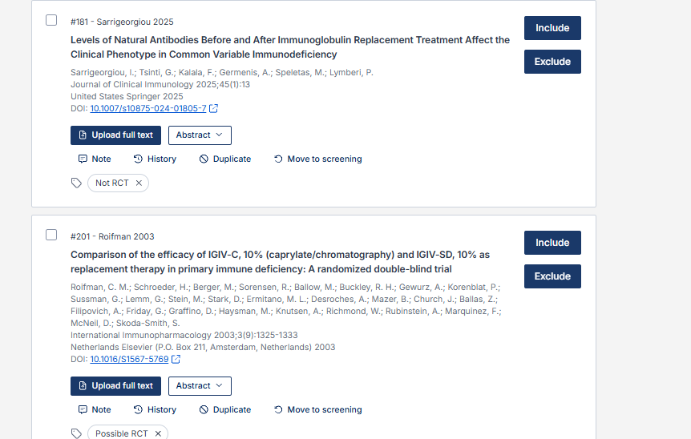
Could you please clarify how I should handle these articles? Should I skip them for now, or am I expected to locate and upload the full texts myself?
I just wanted to confirm this before I begin the screening to avoid any confusion or errors.

